WEEK 3
SUBJECT: NUMERACY  Date: |  | Day: MONDAY |  |  | Strand: All Around Us
 |  |  |  |  | Sub Strand: Plants I
Class: KG 1 |  |  | Class Size:
Content Standard:  K1.6.5.1 Demonstrate understanding of the parts of plants and their functions. |  |  |  | Indicator:  K1.6.5.1.6 describing the position and motion of objects in relation to others.
Performance Indicator:  - Learners can talk about the cover page of the book and point to individual words while listening to the teacher read aloud.  - Learners can describing the position and motion of objects in relation to others. |  |  |  |  | Core Competencies:  Communication and collaboration, Critical thinking, Personal Development and Leadership
Keywords: Plants, medicine, shade
Reference : KG Curriculum P.g. 76-79
Phase/Duration | Learners Activities |  |  |  |  | Resources
PHASE 1: STARTER | Let learners sing a song in relation to the lesson  1. Did you enjoy the song?  2. What words did you hear in the song?
PHASE 2: NEW LEARNING  CIRCLE TIME | Engage learners to play the “Sight word wall ball” game.  Use the markers to write 20-25 sight words on index cards.  Attach the index cards to an outside wall using masking tape, or to an inside wall using painter’s tape. Tape them far enough apart both horizontally and vertically that it’s easy to see which word your learners is aiming at.  Call out one of the words. When your learner locates the word on the wall, let him throw the ball at the correct card. Repeat this until he’s had a chance to try hit all of the words.  Next, let your learner decide which words to aim at. Have him point to and read a word and try to hit it with the ball.
GROUP ACTIVITY 1  (OUTDOOR) | Show your Big Book to learners. Talk about the cover page. Have learners identify the color and some letters written on the book e.g. 1. Title of the page  2. Name of the writer  3. Name of the illustrator  4. Color of the book  Run a pointer under the words as you read aloud to learners, the text on plants. Pause and ask questions about the parts of the plant and it uses.  Uses of plants.  Plants are used as  1. medicine  2. food  3. shelter  4. fruits  Have learners give example of each;  E.g. food- yam, cassava  Fruits – orange, banana, pineapple  Shelter – it is used for building we sit under trees We get fruits from plants.  Have learners retell the story, read to them.  1 medicine  2 food  3 fruits  4 shelter  Let them form sentences orally with the key words.  E.g. a. I don’t like medicine.  b. I eat fruits everyday  Assessment  Have learners work in pairs. They form oral sentence each of the words listed above. |  |  |  |  | Sample young plants, pictures, the Big book, pencils and crayons.
PHONICS | Engage learners to sing songs and recite some familiar rhymes that relates to the target sound.  Guide learners to pronounce and write the target sound in the sand tray or exercise books.  Have learners say three or four words that contain the target sound.  Using flash cards, learners read words that contain the target sound.  1. What sound have we learnt today?  2. Which other letter sound do you know?  3. Mention any object in the classroom or home that begins with the target letter sound. |  |  |  |  | Word cards, letter cards.
GROUP ACTIVITY 2  (INDOOR) | As part of the pre-reading activities, show and talk about the cover page, let learners identify the color and some letters written on the book e.g. title of the book, name of the writer, etc.  Run a pointer under the words while reading, use questions to encourage learners talk about parts and usefulness of plants to human beings as they listen to a read aloud story on plants (the last tree dies the last man dies)  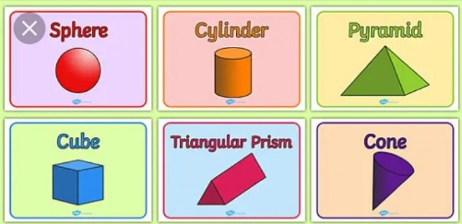  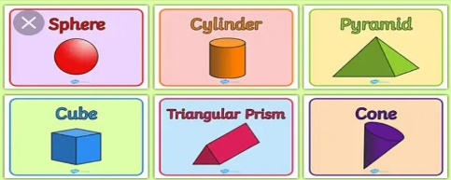  In addition to the picture of trees in the book, display 3-D objects with varied attributes and have leaners touch and feel during the discussion.  Guide learners to describe the given 3-D objects according to a given attribute.  e.g. shape, size etc. with words, phrases, sentences like “round”, “flat”,  “The book is flat”, “A pencil rolls”, “An eraser is smaller than a book”  Recap lessons of position of objects. Using pictures of different kinds of plants, guide learners to identify and talk about the position of each of the plants.  E.g. The flower is the 1st. Ask learners to color a particular position.  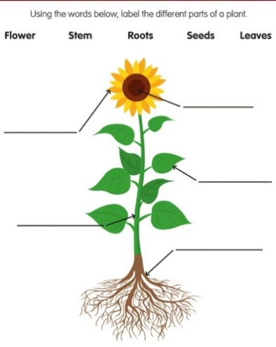
LEARNING CENTER | Engage learners to play freely at the learning centers.  Observe, join in and ask learners questions frequently to guide their play and to support their understanding in what they are learning. |  |  |  |  | Learning center
STORY SHARING | Tell learners a story.  Pause regularly and ask questions to make sure learners are following.  Engage learners to act parts of the story.  1. Was the story interesting?  2. What part of the story did you like?  3. what have you learnt from the story? |  |  |  |  | Word cards, letter cards.
PHASE 3: REFLECTION | Learners share what they have learnt with their peers and class.  Give learners homework to do at home.

SUBJECT: CREATIVE ARTS  Date: |  |  | Day: TUESDAY |  | Strand: All Around Us
 |  |  |  |  | Sub Strand: Plants I
Class: KG 1 |  | Class Size:
Content Standard:  K1.6.5.1 Demonstrate understanding of the parts of plants and their functions. |  |  |  | Indicator:  K1.6.5.1.5 Make art works with the elements of art.
Performance Indicator:  - Learners can sing and talk about parts of a plants and their functions  - Learners can make art works with the elements of art |  |  |  |  | Core Competencies:  Communication and collaboration, Critical thinking, Personal Development and Leadership
Keywords: Plant, stem, root, leaves, fruits
Reference : KG Curriculum P.g. 76-79
Phase/Duration | Learners Activities |  |  |  |  | Resources
PHASE 1: STARTER | Let learners sing a song in relation to the lesson  1. Did you enjoy the song?  2. What words did you hear in the song?
PHASE 2: NEW LEARNING  CIRCLE TIME | Engage learners to play the “Label the Class,” game.  Walk around each learning center with your learners. As they name the items at the various centers, use a permanent marker to write the names on index cards or sentence strips.  Attach them to the item, with tape, in an unobtrusive place.  Each time your child sits on, opens, sleeps in, or otherwise uses one of these items, draw her attention to the card and ask them to read it.  To make the game a little more interesting, you can even ask your learners to use the word in a sentence, such as, “this is Madam’s chair and I’m not supposed to sit in it,” or “I hate to brush my teeth every night!”
GROUP ACTIVITY 1  (OUTDOOR) | Using a picture or a real plant, guide learners to point to and name the part (roots, stem, leaf/leaves).  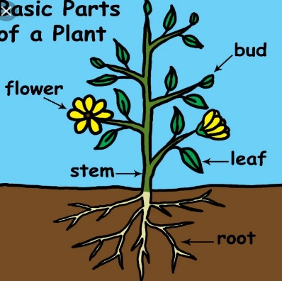  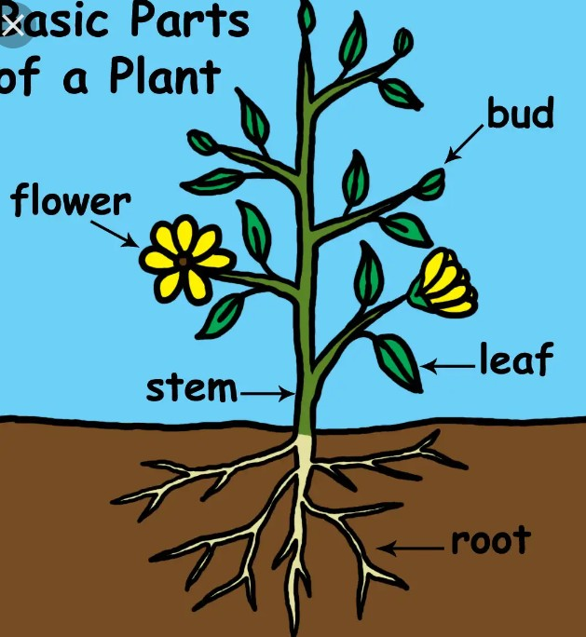  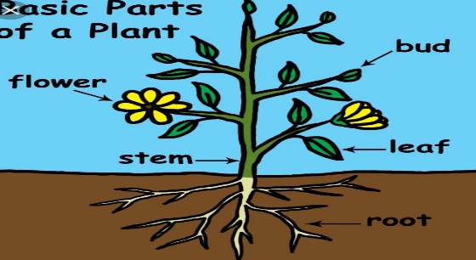  After detailed discussion have learners make sentences with the parts of plant.  e.g. this is the leaf, this is the roots.  Post a drawn tree on the board, using word cards, have learners pick and post the card at the appropriate part.  Repeat the activity to ensure that learners can identify the main parts of a tree.  Using a poster or picture, have learners draw, color and label a plant and talk about their drawing using the right terms/names.  Using leaves and saw dust, guide learners to make a collage of a tree and talk about their art work indicating the parts of a plant.  Using positive language, have learners make simple sentence about their art work. |  |  |  |  | Sample young plants, pictures, the Big book, pencils and crayons.
PHONICS | Engage learners to sing songs and recite some familiar rhymes that relates to the target sound.  Guide learners to pronounce and write the target sound in the sand tray or exercise books.  Have learners say three or four words that contain the target sound.  Using flash cards, learners read words that contain the target sound.  1. What sound have we learnt today?  2. Which other letter sound do you know?  3. Mention any object in the classroom or home that begins with the target letter sound. |  |  |  |  | Word cards, letter cards.
GROUP ACTIVITY 2  (INDOOR) | Give each child a plant (Note: make sure the plant is not harmful  Guide learners to point to and name the parts (root, leaves, stem).  Display a well labelled drawn plant on the board. Mention a part, and let learners point it on the board.  Give out cut-out cards of the plants. Play “pick and act”. One picks say roots and he/she goes to match it on the correct place of the plant on the board.  Play: “How many to make 5?” Show a number of fingers and learners call out a number when added to the fingers shown will make 5. E.g. 1) 1 → 4 2) 3 → 2  Pick a numeral card and show it to learners. Ask them to pick numeral cards sum up to 5 the cards should be displayed on the board as follows.  Put learners into a groups of four. Give them numeral cards. Direct them to pick the numeral card 6.  Now ask learners to pick three (3). 2 numbers which sum up to 6.  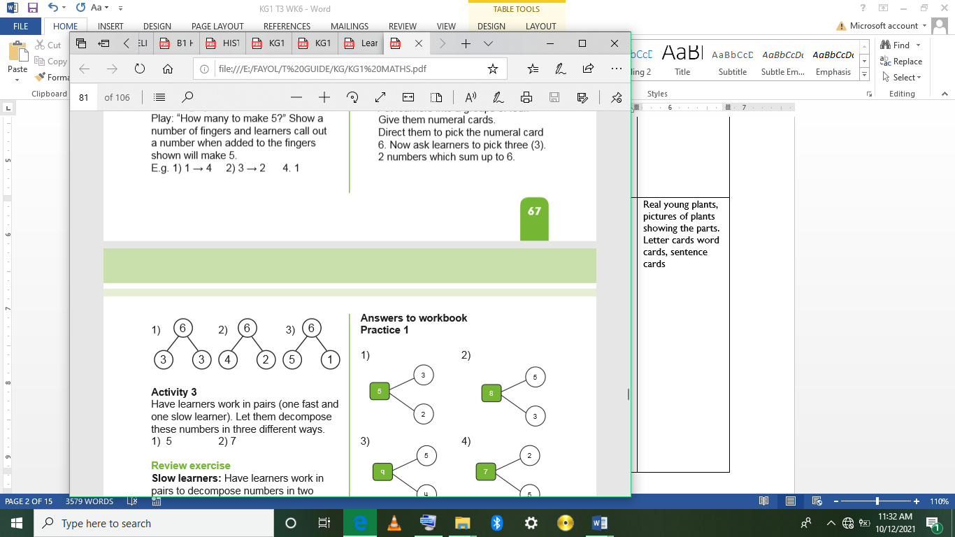  Have learners work in pairs (one fast and one slow learner).  Let them decompose these numbers in three different ways. 1) 5 2) 7  Assessment  Have learners work in pairs to decompose numbers in two different ways. 1) 4 2) 6  Have learners work in pairs to decompose these numbers in 3 different ways. 1) 7 2) 9 3) 10  Have learners work in pairs. Give them cut-out cards of stem, root, leaf. When you pick it you mention/read it. |  |  |  |  | Real young plants, pictures of plants showing the parts. Letter cards word cards, sentence cards
LEARNING CENTER | Engage learners to play freely at the learning centers.  Observe, join in and ask learners questions frequently to guide their play and to support their understanding in what they are learning. |  |  |  |  | Learning center
STORY SHARING | Tell learners a story.  Pause regularly and ask questions to make sure learners are following.  Engage learners to act parts of the story.  1. Was the story interesting?  2. What part of the story did you like?  3. what have you learnt from the story? |  |  |  |  | Word cards, letter cards.
PHASE 3: REFLECTION | Learners share what they have learnt with their peers and class.  Give learners homework to do at home.

SUBJECT: OWOP  Date: |  | Day: WEDNESDAY |  |  | Strand: All Around Us
 |  |  |  |  | Sub Strand: Plants I
Class: KG 1 |  |  | Class Size:
Content Standard:  K1.6.5.1 Demonstrate understanding of the parts of plants and their functions. |  |  |  | Indicator:  K1.6.5.1.1. sing and talk about parts of a plants and their functions  K1.6.5.1.6 describe the position and motion of objects in relation to others
Performance Indicator:  - Learners can sing and talk about parts of a plants and their functions  - Learners can describe the position and motion of objects in relation to others. |  |  |  |  | Core Competencies:  Communication and collaboration, Critical thinking, Personal Development and Leadership
Keywords: Position sentence, blowing breath, blow.
Reference : KG Curriculum P.g. 76-79
Phase/Duration | Learners Activities |  |  |  |  | Resources
PHASE 1: STARTER | Let learners sing a song in relation to the lesson  1. Did you enjoy the song?  2. What words did you hear in the song?
PHASE 2: NEW LEARNING  CIRCLE TIME | Teacher, or learner begins by saying "I spy with my little eye something beginning with.....".  The item has to be something within sight of the learners.  Other learners guess until someone guesses correctly. It can also be played with names; "I spy with my little eye someone beginning with..... ".
GROUP ACTIVITY 1  (OUTDOOR) | In a community circle time, let learners sing songs about plants and discuss the parts.  Using a picture or a real plant, guide learners to point to and name the part (roots, stem, leaf/leaves).  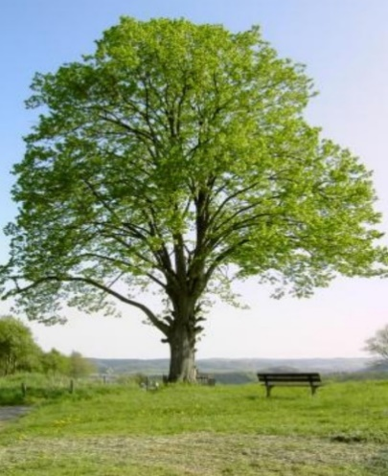  After detailed discussion have learners make sentences with the parts of plant e.g. this is the leaf, this is the roots.  Post a drawn tree on the board, using word cards, have learners pick and post the card at the appropriate part.  Roots  Leaves  Fruits  trunk  Repeat the activity to ensure that learners can identify the main parts of a tree.  Using a poster or picture, have learners draw, color and label a plant and talk about their drawing using the right terms/names.  Recap lessons of position of objects.  Using pictures of different kinds of plants, guide learners to identify and talk about the position of each of the plants.  E.g. The flower is the 5th. Ask learners to color a particular position.  Extend the activities to include number/object grid |  |  |  |  | Sample young plants, pictures, the Big book, pencils and crayons.
PHONICS | Engage learners to sing songs and recite some familiar rhymes that relates to the target sound.  Guide learners to pronounce and write the target sound in the sand tray or exercise books.  Have learners say three or four words that contain the target sound.  Using flash cards, learners read words that contain the target sound.  1. What sound have we learnt today?  2. Which other letter sound do you know?  3. Mention any object in the classroom or home that begins with the target letter sound. |  |  |  |  | Word cards, letter cards.
GROUP ACTIVITY 2  (INDOOR) | Put learners in a community circle. Show real plants to learners. Note: (select plants which are not harmful).  Point to the leaves and tell them the name. Point to the stem and call its name. Point to the roots and let learner call the name after you.  Field trip: Go outside with the class. Show them different types of plants, big trees and small ones. Let them touch the leaves, stem, roots and the flowers.  Review exercise Have learners work in pairs. Give them a plant. They look at it carefully and learn the parts. (stem, root, leaves).  Play: “How many to make 5?” Show a number of fingers and learners top up to make 5.  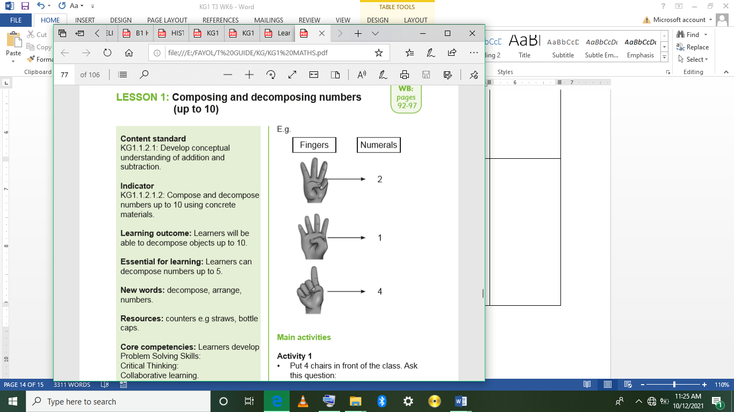  Put 4 chairs in front of the class. Ask this question:  1. How many to make 6?  2. Learners count on and add 2 chairs to make 6.  Call 4 girls to the front of the class. Ask the girls in the class:  How many more to make the girls 7?  Let 3 girls join them, counting on as 4,5,6,7.  Repeat this activity with 5 boys. Ask: How many to make 9?  Then 4 boys join them. In each case let learners form a line.  Put learners into groups of three. Give them 10 counters.  Ask them to decompose them in 3 different ways.  10 as 7 and 3, 6 and 4, 5 and 5, 3 and 7 , 2 and 8.  Have learners work in pairs. Ask them to decompose 7 in 3 different ways. Let them use counters  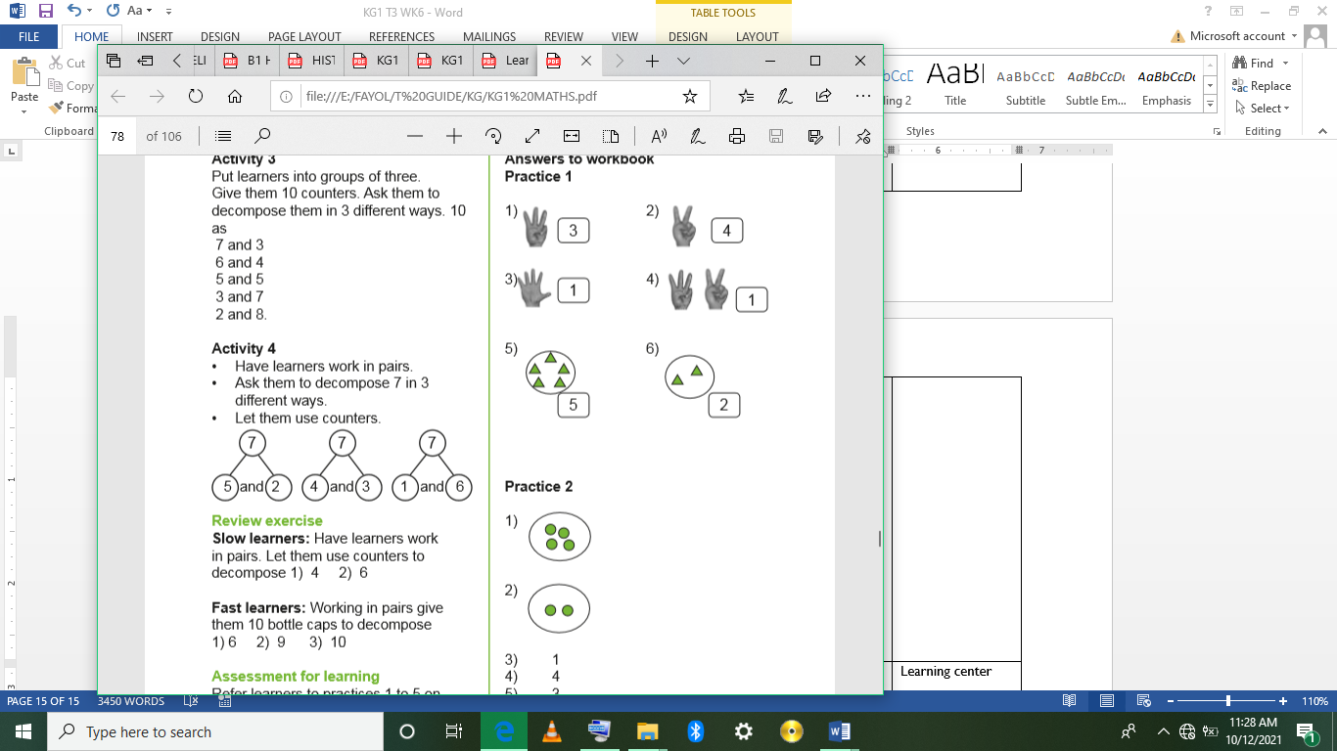  Assessment  Have learners work in pairs. Let them use counters to decompose 1) 4 2) 6  Working in pairs give them 10 bottle caps to decompose  1) 6 2) 9 3) 10
LEARNING CENTER | Engage learners to play freely at the learning centers.  Observe, join in and ask learners questions frequently to guide their play and to support their understanding in what they are learning. |  |  |  |  | Learning center
STORY SHARING | Tell learners a story.  Pause regularly and ask questions to make sure learners are following.  Engage learners to act parts of the story.  1. Was the story interesting?  2. What part of the story did you like?  3. what have you learnt from the story? |  |  |  |  | Word cards, letter cards.
PHASE 3: REFLECTION | Learners share what they have learnt with their peers and class.  Give learners homework to do at home.

SUBJECT: LANG & LIT  Date: |  | Day: THURSDAY |  |  | Strand: All Around Us
 |  |  |  |  | Sub Strand: Plants I
Class: KG 1 |  |  | Class Size:
Content Standard:  K1.6.5.1 Demonstrate understanding of the parts of plants and their functions. |  |  |  | Indicator:  K1.6.5.1.2 talk about the cover page of the book and point to individual words while listening to the teacher read aloud.  K1.6.5.1.3 Blend individual sounds and decode simple words which relates to the theme  K1.6.5.1.4 use a variety of new vocabulary learnt about plants to make simple sentences, draw and write the initial letter sounds.
Performance Indicator:  Learners can  - talk about the cover page of the book and point to individual words while listening to the teacher read aloud.  - Blend individual sounds and decode simple words which relates to the theme  - Learners can use a variety of new vocabulary learnt about plants to make simple sentences, draw and write the initial letter sounds |  |  |  |  |  | Core Competencies:  Communication and collaboration, Critical thinking, Personal Development and Leadership
Keywords: decode, blend, initial.
Reference : KG Curriculum P.g. 76-79
Phase/Duration | Learners Activities |  |  |  |  |  | Resources
PHASE 1: STARTER | Let learners sing a song in relation to the lesson  1. Did you enjoy the song?  2. What words did you hear in the song?
PHASE 2: NEW LEARNING  CIRCLE TIME | Engage learners to play “Step forward” game.  Learners stand at the start line. Teacher calls out 'if you have a /t/ in your name step forward' or 'if your name begins with /f/ step forward'.  The person to get to the finish line wins.
GROUP ACTIVITY 1  (OUTDOOR) | Show your Big Book to learners. Talk about the cover page. Have learners identify the color and some letters written on the book e.g. 1. Title of the page  2. Name of the writer  3. Name of the illustrator  4. Color of the book  Run a pointer under the words as you read aloud to learners, the text on plants. Pause and ask questions about the parts of the plant and it uses.  Uses of plants.  Plants are used as  1. medicine  2. food  3. shelter  4. fruits  Have learners give example of each;  E.g. food- yam, cassava  Fruits – orange, banana, pineapple  Shelter – it is used for building we sit under trees We get fruits from plants.  Have learners retell the story, read to them.  1 medicine  2 food  3 fruits  4 shelter  Let them form sentences orally with the key words.  E.g. a. I don’t like medicine.  b. I eat fruits everyday  Assessment  Have learners work in pairs. They form oral sentence each of the words listed above.  Display a well labeled plant on the board. Recap lesson one of the parts of a plant and take learners through the words again by reading and spelling.. 1 stem, roots, leaves, plants.  Point to a part of a plant and learners mention its name.  Assist learners to identify the initial letter sounds. Have learners play “show and tell” or letter hunt”. You pick the word; say ‘root’ and you identify the initial letter sounds /r/.  Write the words on the board. Let them read and spell the words. Call learners to go to the board and underline the ‘initial’ letter sounds Eg. Stem.  Put learners into groups of four. Give each group a young plant (make sure you take plants which are not harmful).  Ask them to identify the parts. Let them use think-pair-share strategy. They should touch, observe and feel the plants.  Ask whether they can come out with the names of parts of plants. If they are not able, introduce the names to them.  Hold the parts, show it to them. Let them hold theirs and introduce the names to them.  Assessment  Have learners work in pairs to indicate the initial letter sounds of these words.  1. medicine. 2. fruits. 3. stem.  Guide them to make a collage of their drawing. Have learners display their artworks for others to appreciate |  |  |  |  |  | Letter cards, word cards about plants, pencils, crayons
PHONICS | Engage learners to sing songs and recite some familiar rhymes that relates to the target sound.  Guide learners to pronounce and write the target sound in the sand tray or exercise books.  Have learners say three or four words that contain the target sound.  Using flash cards, learners read words that contain the target sound.  1. What sound have we learnt today?  2. Which other letter sound do you know?  3. Mention any object in the classroom or home that begins with the target letter sound. |  |  |  |  |  | Word cards, letter cards.
GROUP ACTIVITY 2  (INDOOR) | Using a clearly labelled tree, recap lessons on the parts of tree and take learners through the keywords, guide them to identify the initial letter sounds.  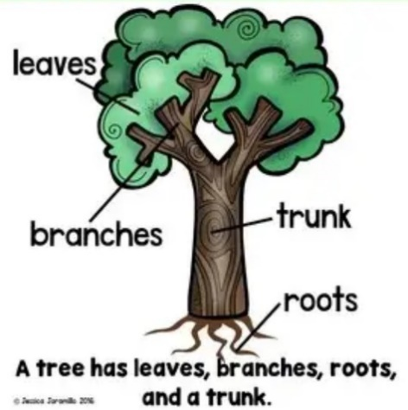  Have learners play “Show and tell” or “Letter hunt” to highlight the initial sound of the words.  Ask learners to draw and indicate the initial letter sounds of the parts.  Using leaves and saw dust, guide learners to make a collage of a tree and talk about their art work indicating the parts of a plant.  Using positive language, have learners make simple sentence about their art work.  Learners sing rhymes and dance with actions.
LEARNING CENTER | Engage learners to play freely at the learning centers.  Observe, join in and ask learners questions frequently to guide their play and to support their understanding in what they are learning. |  |  |  |  |  | Learning center
STORY SHARING | Tell learners a story.  Pause regularly and ask questions to make sure learners are following.  Engage learners to act parts of the story.  1. Was the story interesting?  2. What part of the story did you like?  3. what have you learnt from the story? |  |  |  |  |  | Word cards, letter cards.
PHASE 3: REFLECTION | Learners share what they have learnt with their peers and class.  Give learners homework to do at home.

